**SECTION A**

**Attempt** any three **questions**

1. Define the following terms. (@01 mark)
2. Eutectic point.
3. Eutectic mixture.
4. The melting points of pure cadmium and bismuth are **321ᵒC** and **271ᵒC** respectively. The table below shows the melting points and compositions of various mixtures of cadmium and bismuth.

|  |  |  |  |  |  |  |
| --- | --- | --- | --- | --- | --- | --- |
| Percentage of cadmium | 20 | 35 | 50 | 65 | 80 | 95 |
| Melting points (ᵒC) | 226 | 190 | 156 | 184 | 242 | 300 |

1. Draw a well-labelled phase diagram of cadmium-bismuth system. (04 marks)
2. State the composition and melting point of the eutectic mixture. (02 marks)
3. Explain the shape of the diagram. (04 marks)
4. Describe the phase changes that take place when a liquid mixture containing **70%** of cadmium at a temperature of **300ᵒC** is gradually cooled. (04 marks)
5. State **2** each similarities and differences between a eutectic and a pure compound. (04 marks)
6. **Hydrocarbon, P** on complete combustion gave **8.8g** of carbon dioxide gas and **1.8g** of steam. **0.1g** of **hydrocarbon, P** occupied **44.6cm3** at a temperature of **273ᵒC** and a pressure of **734mmHg** when vaporized.
7. Calculate the:
8. Empirical formula of hydrocarbon, P. (02 marks)
9. Relative molecular mass of hydrocarbon, P. (02 marks)
10. Determine the molecular formula and write the structural formula of hydrocarbon, P. (01½ marks)
11. Write the equation and indicate the mechanism for the reaction between hydrocarbon, P and bromine water. (03 marks)
12. Write equations to show how hydrocarbon, P can be:
13. Synthesized from benzene. (04 marks)
14. Converted to polyphenylethene. (Polystyrene). (01 mark)
15. When hydrocarbon, P was ozonide and the product hydrolyzed, it formed an aromatic product, Q.
16. Write the equation for the reaction that took place and name the product, Q. (01½ marks)
17. Write the equation and indicate the mechanism for the reaction between product, Q and solution of 2, 4- dinitrophenylhydrazine [Brady’s reagent]. (04½ marks)
18. State what is observed in (ii) above. (0½ mark)
19. The elements sodium, aluminium, silicon, phosphorous, sulphur & chlorine belongs to period (III) of the periodic table.
20. Describe the reaction of the hydrides of sodium, silicon and sulphur with water. (06 marks)
21. Describe the reactions of:
22. Aluminium, silicon & chlorine with aqueous sodium hydroxide solution. (08 marks)
23. Aluminium with sulphuric acid. (02 marks)
24. Aluminium oxide and silicon dioxide with aqueous sodium hydroxide solution. (04 marks)
25. State Raoult’s law and mention its limitations. (02 marks)
26. Explain:
27. What is meant by an ideal solution? (02 marks)
28. Why some liquid mixture do not obey Raoult’s law. (04 marks)
29. The vapour pressure of a solution containing 1mole of A and 4moles of B is 0.75atmosphere at a room temperature. At the same temperature the vapour pressures of pure A and B are 0.674 & 0.453 atmospheres respectively.
30. Calculate the vapour pressure of the liquid mixture assuming it was ideal. (02 marks)
31. State how the mixture deviates from Raoult’s law. Explain your answer. (02 marks)
32. Calculate the composition of the vapour above the liquid mixture assuming its ideal. (02 marks)
33. Sketch a labeled temperature-composition diagram for the mixture of A & B. (03 marks)
34. State each 1 similarity and difference between an azeotropic mixture and a compound. (02 marks)

**SECTION b**

**Attempt** only two **questions in this section.**

1. Explain the following observations.
2. 2-methylpropene react with bromine water to form 1-bromo-2-methyl propan-2-ol but not 1,2-dibromo-2-methylpropane. (05 marks)
3. Phenolphthalein is used to determine the end-point in the titration of ethanoic acid with sodium hydroxide solution whereas methylorange is used in the titration of nitric acid with ammonia solution. (04 marks)
4. Methanoic acid reacts with a solution of silver nitrate in ammonia while ethanoic acid does not. (03 marks)
5. Water is a liquid while hydrogen sulphide is a gas. (04 marks)
6. Propene undergoes electrophilic addition reaction whereas propanone undergoes nucleophilic addition reaction. (04 marks)
7. Write equations to show how the following compounds can be synthesized. In each case indicate the reagents and conditions.
8. Phenylethanoate from benzene. (04 marks)
9. Propanoic acid from propyne. (04 marks)
10. 2,2-dichloropropane from propan-1-ol. (04 marks)
11. 1-methylcyclohexan-1-ol from phenol. (06 marks)
12. Ethanaloxime from but-2-ene. (02 marks)
13. Write the formula and name of one ore of zinc. (01 mark)
14. Describe how:
15. Ore is concentrated. (04 marks)
16. Pure zinc is obtained from the concentrated ore. (06 marks)
17. Describe the reaction of zinc with:
18. Sulphuric acid. (04 marks)
19. Saqueous sodium hydroxide solution. (02 marks)
20. Briefly explain why a solution of zinc sulphate is acidic. (03 marks)
21. Define:
22. Conductivity.
23. Molar conductivity.
24. The table below shows the molar conductivities of sodium hydroxide solution of different concentrations.

|  |  |  |  |  |  |  |
| --- | --- | --- | --- | --- | --- | --- |
| Concentration/mol/dm3 | 0.01 | 0.04 | 0.09 | 0.16 | 0.25 | 0.36 |
| Molar conductivity Ω-1cm2/mol | 238 | 230 | 224 | 217 | 210 | 202 |

1. Plot a graph of molar conductivity against the square root of concentration. (04 marks)
2. Explain the shape of the curve. (04½ marks)
3. Determine the molar conductivity of sodium hydroxide solution at infinite dilution. (01 mark)
4. The electrolytic conductivity of a 0.015M solution of propanoic acid at room temperature is 1.75 x 10-2S/m. It’s molar conductivity at infinite dilution is 3.53 x 10-2S/m. Calculate the:
5. Molar conductivity of the solution of propanoic acid at 25ᵒC.
6. Degree of ionization. (iii). pH of the solution.
7. **25.0cm3** of **0.1M** sodium hydroxide solution was titrated against ammonia solution.
8. Draw a sketch graph to show how conductivity changes with concentration. (02 marks)
9. Explain the graph’s shape. (03½ marks)

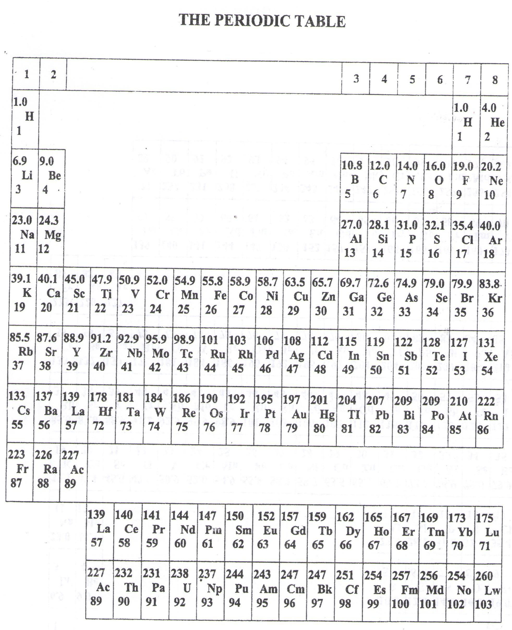

* ===END===

WELCOME TO SENIOR SIX, YEAR 2023

This is the last page of the printed paper, Page 05